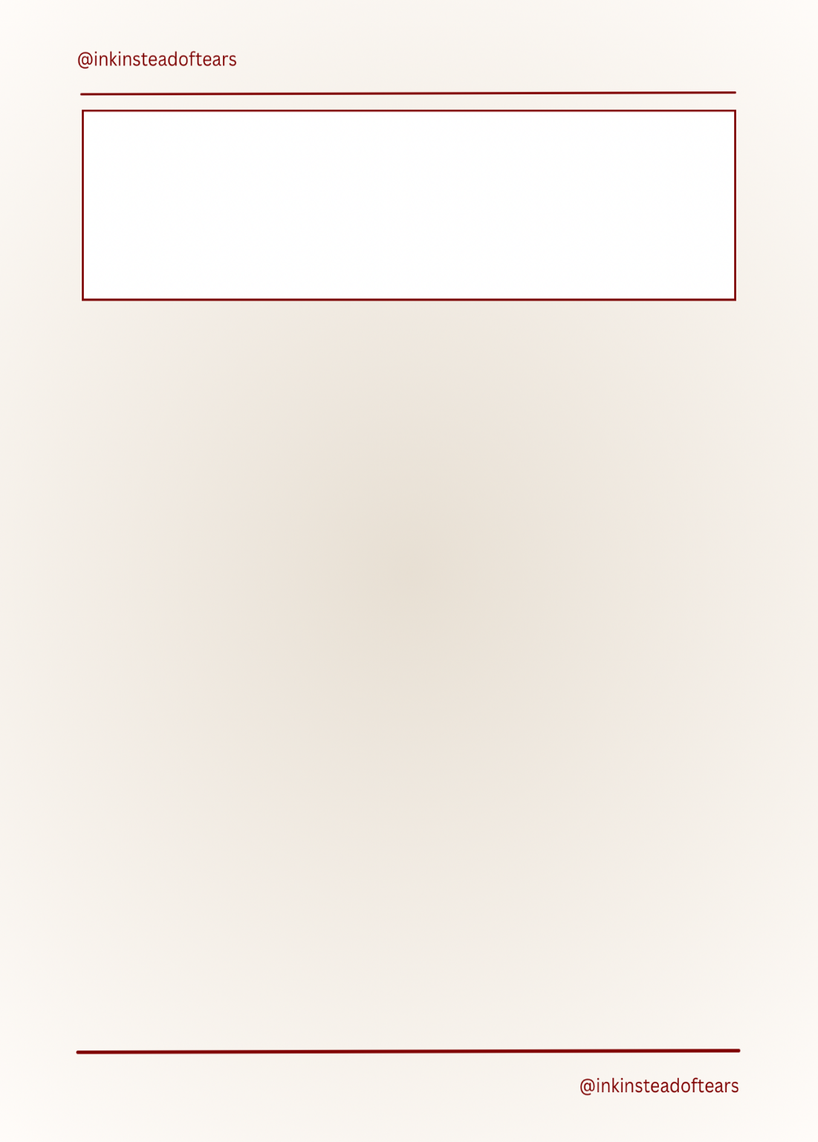

I gave my heart, hoping love would never leave me broken. Every promise I held onto slowly faded into quiet emptiness. **I spent long nights wishing morning would bring me some peace.**

It still hurts even when I try to act like I’m fine. I reach for answers, but the pain keeps following me everywhere. **Sometimes I feel that loving well only brings me more heartbreak.**

I keep dreaming of warmth, even when the world feels cold. **Time can’t erase the hurt, the love I lost stays with me.**

It hurts because I gave everything, but got nothing in return. **Still, I will heal and grow stronger than I ever believed.**